**Unleashing the Potential of Our Youth: A Student Performance Analysis**

This project is about using machine learning algorithms to predict whether or not a student would pass the final exam. The data set used is from UCI Machine Learning Repository.

#### Project contributors :

1. Divya M
2. Femina Shushmi J
3. Frana Shwetha S

**Understanding the Problem Statement:**

This project understands how the student’s performance (test scores) is affected by other variables such as Gender, Ethnicity, Parental level of education, and Lunch and Test preparation course.

The primary objective of higher education institutions is to impart quality education to their students. To achieve the highest level of quality in the education system, knowledge must be discovered to predict student enrollment in specific courses, identify issues with traditional classroom teaching models, detect unfair means used in online examinations, detect abnormal values in student result sheets, and predict student performance. This knowledge is hidden within educational datasets and can be extracted through data mining techniques.

This project focuses on evaluating students’ capabilities in various subjects using a classification task. Data classification has many approaches, and the decision tree method and probabilistic classification method are utilized here. By performing this task, knowledge is extracted that describes students’ performance in the end-semester examination. This helps in identifying dropouts and students who require special attention, enabling teachers to provide appropriate advising and counseling.

## Data Collection

Dataset Source :The data consists of 8 column and 1000 rows.

**Import Data and Required Packages**

Importing Pandas, Numpy, Matplotlib, Seaborn.

**import** pandas **as** pd

**import** numpy **as** np

**import** matplotlib.pyplot **as** plt

**import** seaborn **as** sns

**import** warnings

warnings.**filterwarnings**("ignore")

Import the CSV Data as Pandas DataFrame

df = pd.read_csv("data/StudentsPerformance.csv")

Show the top 5 Recoreds

df.head()

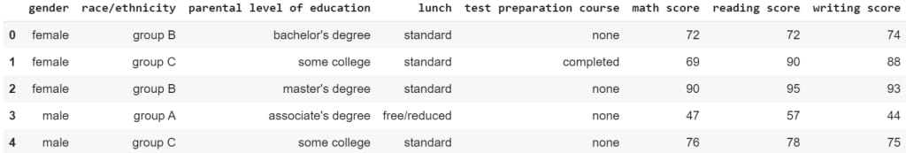

show the top 5 records on the dataset and look at the features.

To see the shape of the dataset

df.shape

47e35ae7-47b3-443c-b511-3298012d6543.jpg

And it will help to find the shape of the dataset.

## Dataset Information

* gender: sex of students -> (Male/female)
* race/ethnicity: ethnicity of students -> (Group A, B, C, D, E)
* parental level of education: parents’ final education ->(bachelor’s degree, some college, master’s degree, associate’s degree)
* lunch: having lunch before test (standard or free/reduced)
* test preparation course: complete or not complete before test
* math score
* reading score
* writing score

After that, we check the data as the next step. There are a number of categorical features contained in the dataset, including multiple missing values kinds, duplicate values, check data types, and a number of unique value types.

## Data Checks to Perform

* Check Missing values
* Check Duplicates
* Check data type
* Check the number of unique values in each column
* Check the statistics of the data set
* Check various categories present in the different categorical column

## Check Missing Values

To check every column of the missing values or null values in the dataset.

df.isnull().sum()

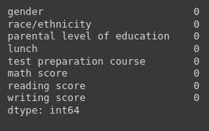

If there are no missing values in the dataset.

## Check Duplicates

If checking the our dataset has any duplicated values present or not

df.duplicated().sum()

7c54d88f-6e63-4ba6-906a-63bba1875859.jpg

There are no duplicates values in the dataset.

## Check the Data Types

To check the information of the dataset like datatypes, any null values present in the dataset.

#check the null and Dtypes

df.info()

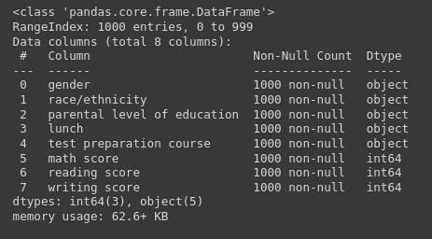

## Check the Number of Unique Values in Each Column

df.nunique()

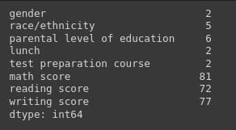

## Check Statistics of the Data Set

To examine the dataset’s statistics and determine the data’s statistics.

## Insight

* The numerical data shown above shows that all means are fairly similar to one another, falling between 66 and 68.05.
* The range of all standard deviations, between 14.6 and 15.19, is also narrow.
* While there is a minimum score of 0 for math, the minimums for writing and reading are substantially higher at 10 and 17, respectively.
* We don’t have any duplicate or missing values, and the following codes will provide a good data checking.

## Exploring Data

print("Categories in 'gender' variable: ",end=" ")

print(df["gender"].unique())

print("Categories in 'race/ethnicity' variable: ",end=" ")

print(df["race/ethnicity"].unique())

print("Categories in 'parental level of education' variable: ",end=" ")

print(df["parental level of education"].unique())

print("Categories in 'lunch' variable: ",end=" ")

print(df["lunch"].unique())

print("Categories in 'test preparation course' variable: ",end=" ")

print(df["test preparation course"].unique())

The unique values in the dataset will be provided and presented in a pleasant way in the code above.

The output will following:

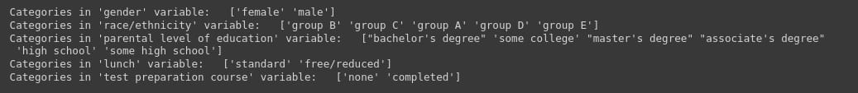

We define the numerical and categorical columns:

#define numerical and categorical columns

numeric_features = [feature **for** feature **in** df.columns **if** df[feature].dtype != "object"]

categorical_features = [feature **for** feature **in** df.columns **if** df[feature].dtype == "object"]

print("We have {} numerical features: {}".format(len(numeric_features),numeric_features))

print("We have {} categorical features: {}".format(len(categorical_features),categorical_features))

The above code will use separate the numerical and categorical features and count the feature values.

da947bd9-e5b2-420c-8812-dd3e09d672a0.jpg

## Exploring Data (Visualization)

#### Visualize Average Score Distribution to Make Some Conclusion

* Histogram
* Kernel Distribution Function (KDE)
* Histogram & KDE

## Gender Column

How is distribution of Gender?

Is gender has any impact on student’s performance?

# Create a figure with two subplots

f,ax=plt.subplots(1,2,figsize=(8,6))

# Create a countplot of the 'gender' column and add labels to the bars

sns.countplot(x=df['gender'],data=df,palette ='bright',ax=ax[0],saturation=0.95)

**for** container **in** ax[0].containers:

ax[0].bar_label(container,color='black',size=15)

# Set font size of x-axis and y-axis labels and tick labels

ax[0].set_xlabel('Gender', fontsize=14)

ax[0].set_ylabel('Count', fontsize=14)

ax[0].tick_params(labelsize=14)

# Create a pie chart of the 'gender' column and add labels to the slices

plt.pie(x=df['gender'].value_counts(),labels=['Male','Female'],explode=[0,0.1],autopct='%1.1f%%',shadow=True,colors=['#ff4d4d','#ff8000'], textprops={'fontsize': 14})

# Display the plot

plt.show()

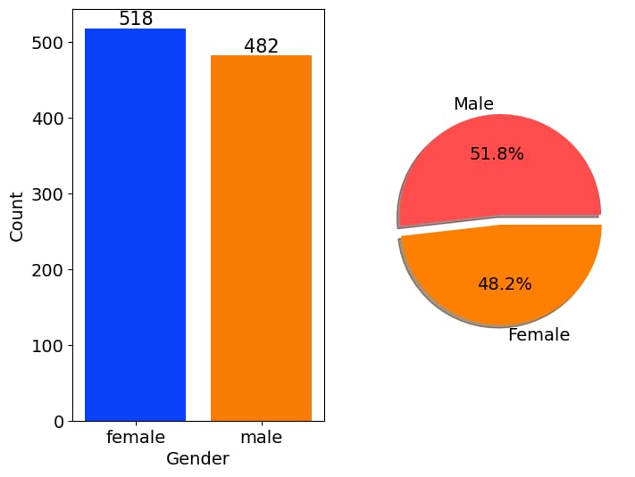

Gender has balanced data with female students are 518 (48%) and male students are 482 (52%)

## Race/Ethnicity Column

# Define a color palette for the countplot

colors = ['#1f77b4', '#ff7f0e', '#2ca02c', '#d62728', '#9467bd']

# blue, orange, green, red, purple are respectiively the color names for the color codes used above

# Create a figure with two subplots

f, ax = plt.subplots(1, 2, figsize=(12, 6))

# Create a countplot of the 'race/ethnicity' column and add labels to the bars

sns.countplot(x=df['race/ethnicity'], data=df, palette=colors, ax=ax[0], saturation=0.95)

**for** container **in** ax[0].containers:

ax[0].bar_label(container, color='black', size=14)

# Set font size of x-axis and y-axis labels and tick labels

ax[0].set_xlabel('Race/Ethnicity', fontsize=14)

ax[0].set_ylabel('Count', fontsize=14)

ax[0].tick_params(labelsize=14)

# Create a dictionary that maps category names to colors in the color palette

color_dict = dict(zip(df['race/ethnicity'].unique(), colors))

# Map the colors to the pie chart slices

pie_colors = [color_dict[race] **for** race **in** df['race/ethnicity'].value_counts().index]

# Create a pie chart of the 'race/ethnicity' column and add labels to the slices

plt.pie(x=df['race/ethnicity'].value_counts(), labels=df['race/ethnicity'].value_counts().index, explode=[0.1, 0, 0, 0, 0], autopct='%1.1f%%', shadow=True, colors=pie_colors, textprops={'fontsize': 14})

# Set the aspect ratio of the pie chart to 'equal' to make it a circle

plt.axis('equal')

# Display the plot

plt.show()

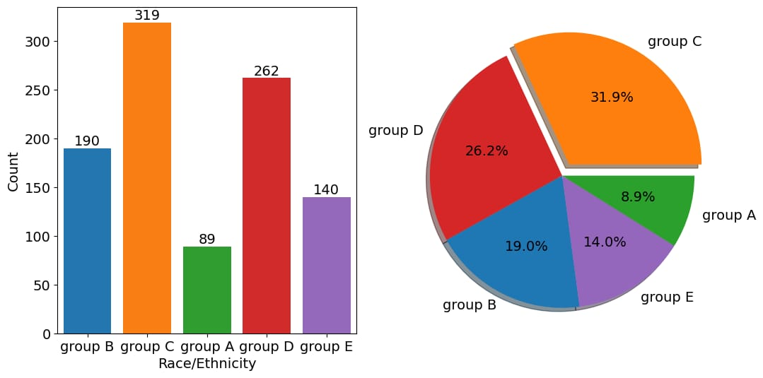

**id = Insights>Insights**

* Most of the student belonging from group C /group D.
* Lowest number of students belong to group A.

## Parental Level of Education Column

plt.rcParams['figure.figsize'] = (15, 9)

plt.style.use('fivethirtyeight')

sns.histplot(df["parental level of education"], palette = 'Blues')

plt.title('Comparison of Parental Education', fontweight = 30, fontsize = 20)

plt.xlabel('Degree')

plt.ylabel('count')

plt.show()

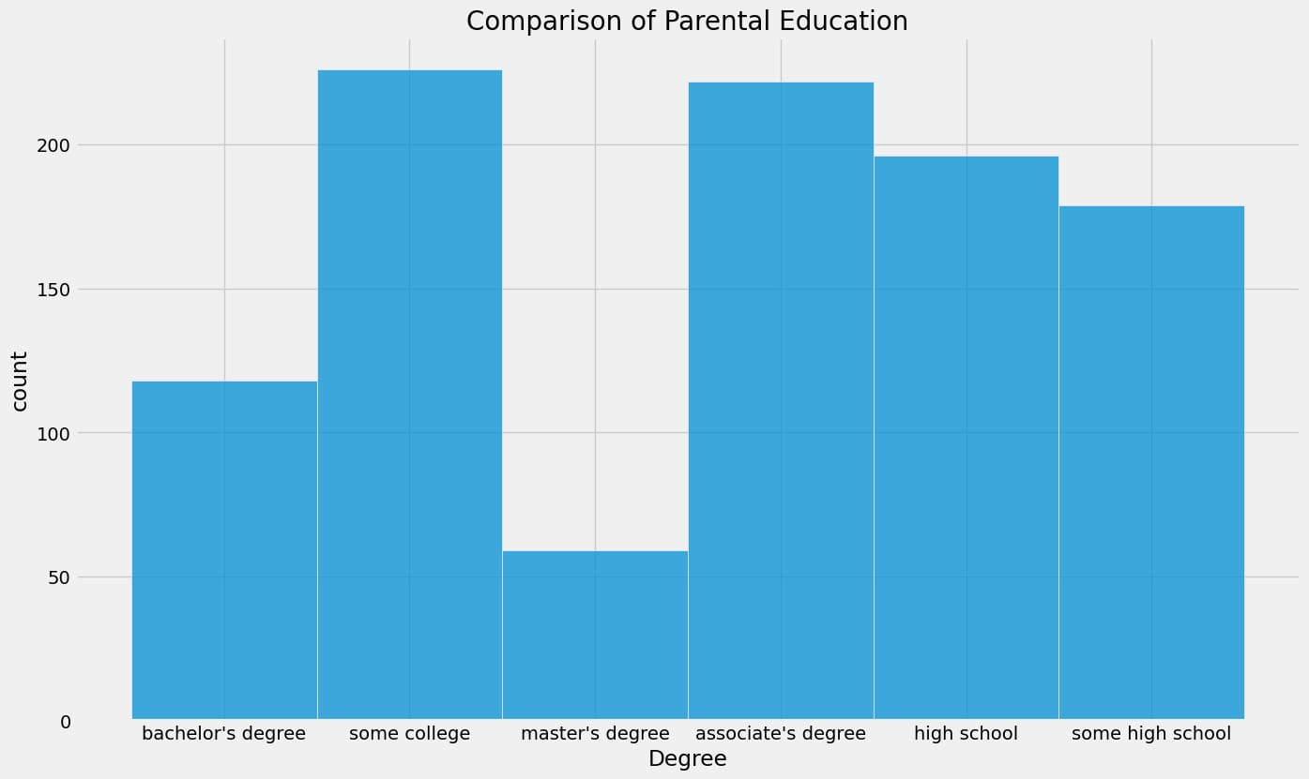

**id = Insights>Insights**

* Largest number of parents are from college.

## Bivariate Analysis

df.groupby('parental level of education').agg('mean').plot(kind='barh',figsize=(10,10))

plt.legend(bbox_to_anchor=(1.05, 1), loc=2, borderaxespad=0.)

plt.show()

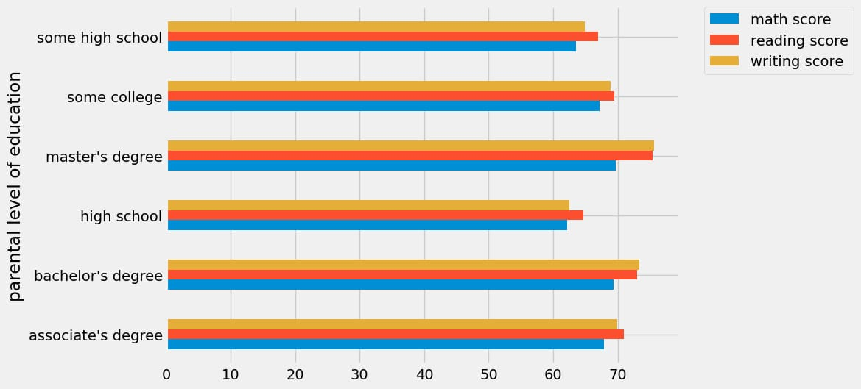

**id = Insights>Insights**

* The score of student whose parents possess master and bachelor level education are higher than others.

## Maximum Score of Students in All Three Subjects

plt.fig

figsize=(18,8))

plt.subplot(1, 4, 1)

plt.title('MATH SCORES')

sns.violinplot(y='math score',data=df,color='red',linewidth=3) plt.subplot(1, 4, 2) plt.title('READING SCORES') sns.vi

plot(y='reading score',data=df,color='green',linewidth=3) plt.subplot(1, 4, 3) plt.title('WRITING SCORES') sns.violinplot(y='writing score',data=df,color='blue',linewidth=3) plt.show()

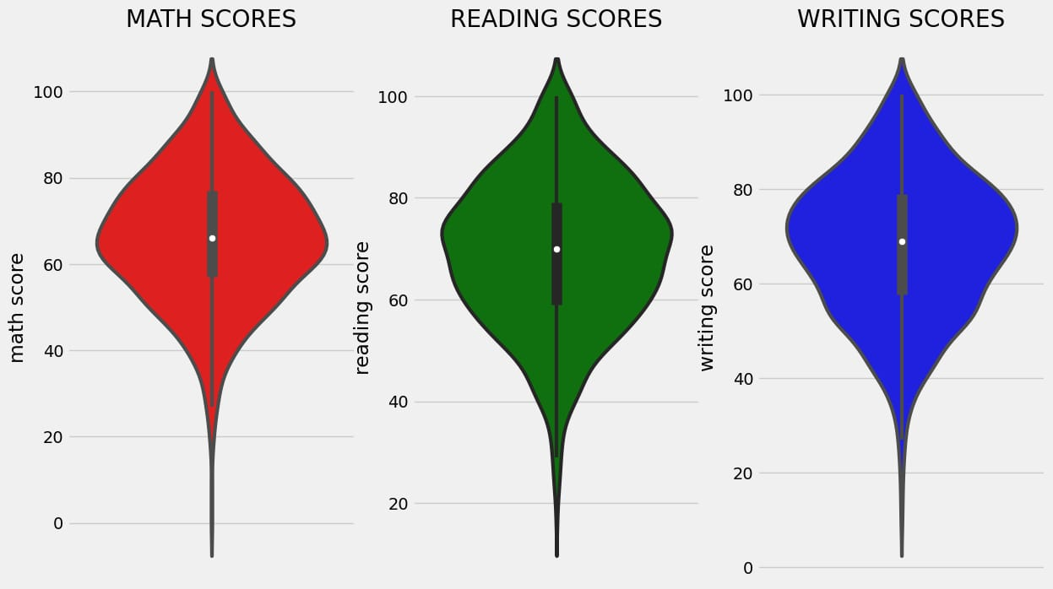

**id = Insights>Insights**

From the above three plots its clearly visible that most of the students score in between 60-80 in Maths whereas in reading and writing most of them score from 50-80.

## Multivariate Analysis Using Pie Plot

# Set figure size

plt.rcParams['figure.figsize'] = (12, 9)

# First row of pie charts

plt.subplot(2, 3, 1)

size = df['gender'].value_counts()

labels = 'Female', 'Male'

color = ['red','green']

plt.pie(size, colors=color, labels=labels, autopct='%.2f%%')

plt.title('Gender', fontsize=20)

plt.axis('off')

plt.subplot(2, 3, 2)

size = df['race/ethnicity'].value_counts()

labels = 'Group C', 'Group D', 'Group B', 'Group E', 'Group A'

color = ['red', 'green', 'blue', 'cyan', 'orange']

plt.pie(size, colors=color, labels=labels, autopct='%.2f%%')

plt.title('Race/Ethnicity', fontsize=20)

plt.axis('off')

plt.subplot(2, 3, 3)

size = df['lunch'].value_counts()

labels = 'Standard', 'Free'

color = ['red', 'green']

plt.pie(size, colors=color, labels=labels, autopct='%.2f%%')

plt.title('Lunch', fontsize=20)

plt.axis('off')

# Second row of pie charts

plt.subplot(2, 3, 4)

size = df['test preparation course'].value_counts()

labels = 'None', 'Completed'

color = ['red', 'green']

plt.pie(size, colors=color, labels=labels, autopct='%.2f%%')

plt.title('Test Course', fontsize=20)

plt.axis('off')

plt.subplot(2, 3, 5)

size = df['parental level of education'].value_counts()

labels = 'Some College', "Associate's Degree", 'High School', 'Some High School', "Bachelor's Degree", "Master's Degree"

color = ['red', 'green', 'blue', 'cyan', 'orange', 'grey']

plt.pie(size, colors=color, labels=labels, autopct='%.2f%%')

plt.title('Parental Education', fontsize=20)

plt.axi

ff') # Remove extra subplot plt.subplot(2, 3, 6).remove() # Add super title plt.suptitle('Comparison of Student Attributes', fontsize=20, fontweight='bold') # Adjust layout and show plot # This is removed as there are only 5 subplots in this figure and we want to arrange them in a 2x3 grid. # Since there is no 6th subplot, it is removed to avoid an empty subplot being shown in the figure. plt.tight_layout() plt.subplots_adjust(top=0.85) plt.show()

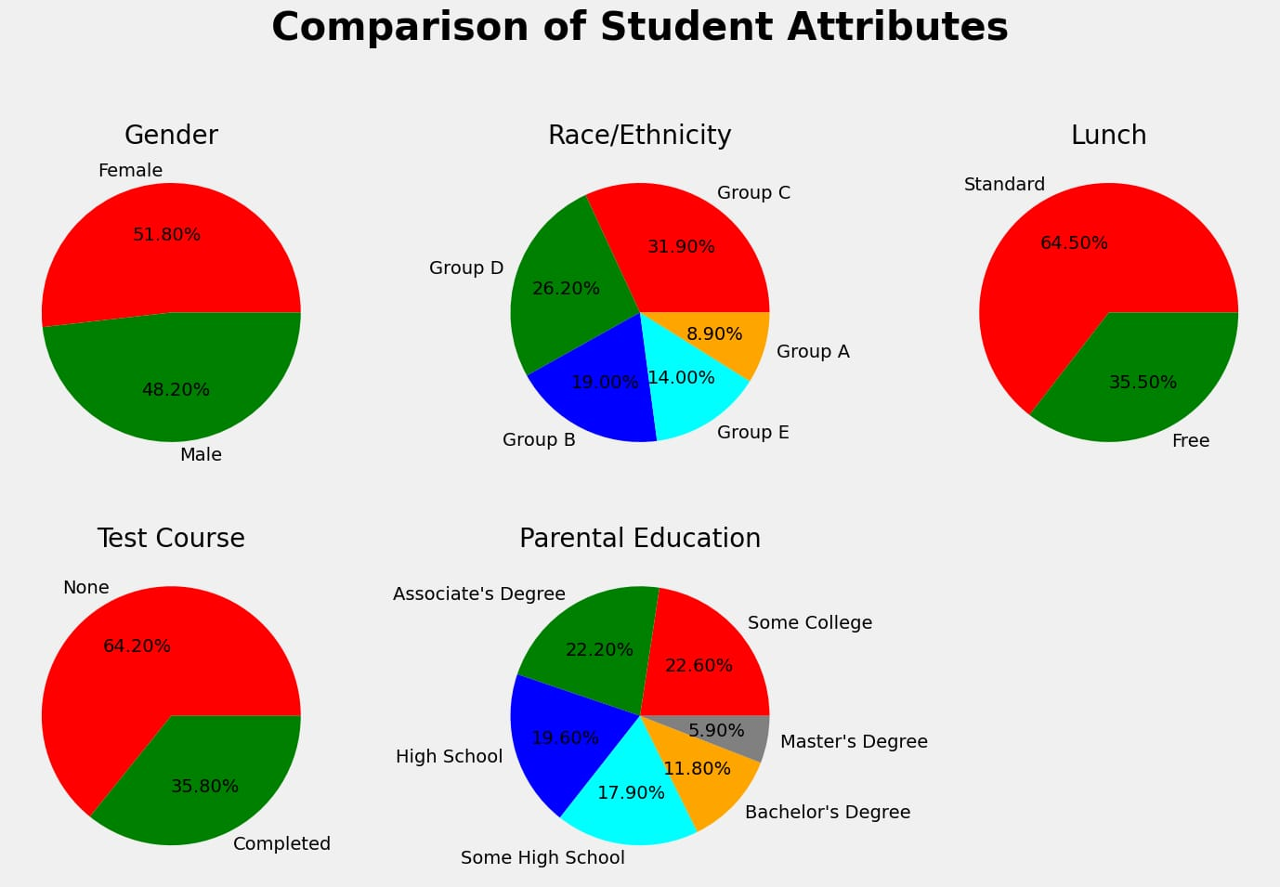

**id = Insights>Insights**

* The number of Male and Female students is almost equal.
* The number of students is higher in Group C.
* The number of students who have standard lunch is greater.
* The number of students who have not enrolled in any test preparation course is greater.
* The number of students whose parental education is “Some College” is greater followed closely by “Associate’s Degree”.

From the above plot, it is clear that all the scores increase linearly with each other.

Student’s Performance is related to lunch, race, and parental level education.

* Females lead in pass percentage and also are top-scorers.
* Student Performance is not much related to test preparation course.
* The finishing preparation course is beneficial.

## Model Training

Import Data and Required Packages

Importing scikit library algorithms  to import regression algorithms.

# Modelling

**from** sklearn.metrics **import** mean_squared_error, r2_score

**from** sklearn.neighbors **import** KNeighborsRegressor

**from** sklearn.tree **import** DecisionTreeRegressor

**from** sklearn.ensemble **import** RandomForestRegressor,AdaBoostRegressor

**from** sklearn.svm **import** SVR

**from** sklearn.linear_model **import** LinearRegression,Lasso

**from** sklearn.metrics **import** r2_score, mean_absolute_error, mean_squared_error

**from** sklearn.model_selection imp

**RandomizedSearchCV** **from** catboost **import** **CatBoostRegressor** **from** xgboost **import** **XGBRegressor** **import** warnings

## Splitting the X and Y Variables

This separation of the dependent variable(y) and independent variables(X) is one the most important in our project we use the math score as a dependent variable. Because so many students lack in math subjects it will almost 60% to 70% of students in classes 7-10 students are fear of math subjects that’s why I am choosing the math score as a dependent score.

It will use to improve the percentage of math scores and increase the grad f students and also remove fear in math.

X = df.drop(columns="math score",axis=1)

y = df["math score"]

## Separate Dataset into Train and Test

To separate the dataset into train and test to identify the training size and testing size of the dataset.

**from** sklearn.model_selection **import** train_test_split

X_train, X_test, y_train, y_test = **train_test_split**(X,y,test_size=0.2,random_state=42)

X_train.shape, X_test.shape

5b27c76a-ed4d-41bb-981a-e1a813edfd35.jpg

.

## Model Selection

This is used to select the best model of all of the regression algorithms.

In linear regression, we got 88.03 curacy in all of the regression models that’s why we choose model.

pd.DataFrame(list(zip(model_list, r2_list)), columns=['Model Name', 'R2_Score']).sort_values(**by**=["R2_Score"],**ascending**=False)

 Accuracy of the model is 88.03%

74cad730-68e8-43c6-b21e-d8245c8d58c4.jpg

plt.scatter(y_test,y_pred)

plt.xlabel('Actual')

plt.ylabel('Predicted')

plt.show()

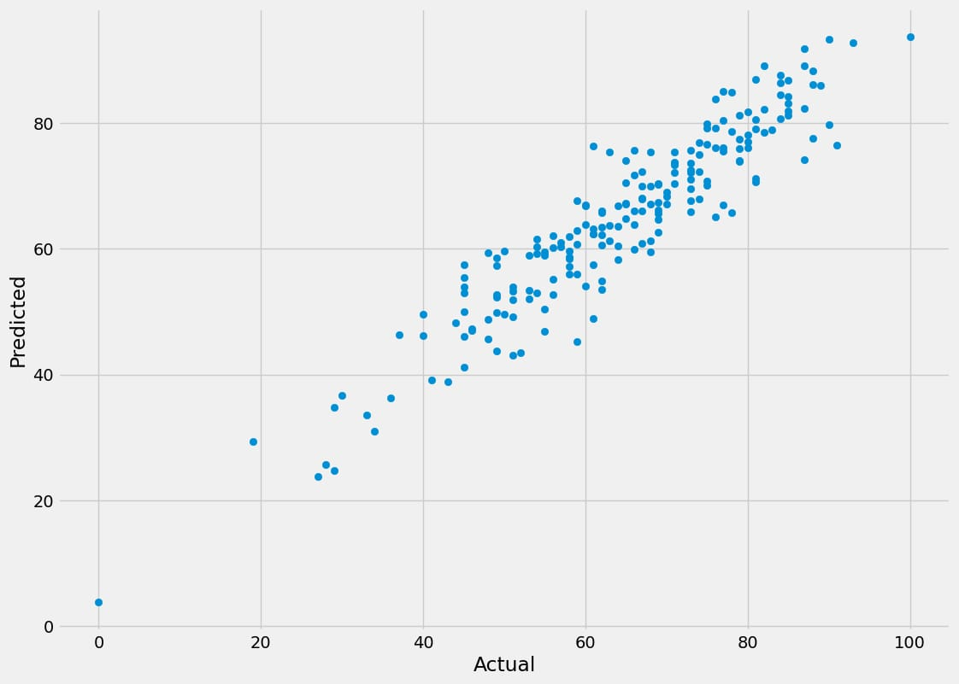

sns.regplot(x=y_test,y=y_pred,ci=None,color ='red')

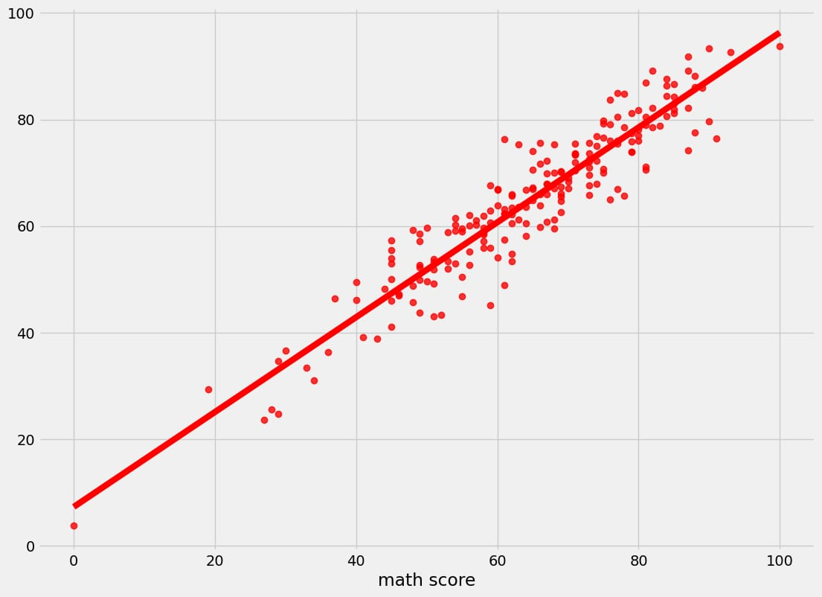

## Difference Between Actual and Predicted Values

pred_df=pd.**DataFrame**({'Actual Value':y_test,'Predicted Value':y_pred,'Difference':y_test-y_pred})

pred_df

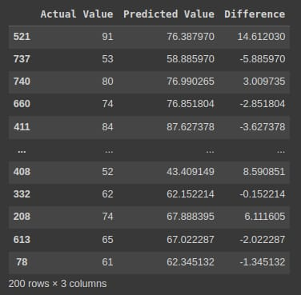

## Conclusion

This brings us to an end to the student’s performance prediction. Let us review our work. First, we started by defining our problem statement, looking into the algorithms we were going to use and the regression implementation pipeline. Then we moved on to practically implementing the identification and regression algorithms like Linear Regression, Lasso, K-Neighbors Regressor, Decision Tree, Random Forest Regressor, XGBRegressor, CatBoosting Regressor, and AdaBoost Regressor. Moving forward, we compared the performances of these models. Lastly, we built a Linear regression model that proved that it works best for student performance prediction problems.

The key takeaways from this  student performance prediction are:

* Identification of student performance prediction is important for many institutions.
* Linear regression gives better accuracy compared to other regression problems.
* Linear regression is the best fit for the problem
* Linear regression provides an accuracy of 88%, giving out the most accurate results.